**Jenkins Master-Slave setup:**

Master-Slave architecture:

---> In Jenkins, the Master is also called as controller and it is the main server that manages the Jenkins environment.

---> Controller is the responsible for scheduling jobs, managing configuration and monitoring nodes.

--->In Jenkins, Slave is also called as Agent and it was a different machine actually runs the build or job assigned by the master.

This setup allows Jenkins to **distribute workloads** across multiple systems for better performance and scalability.

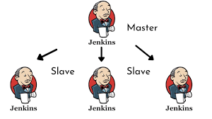

**Step-1:**

Jenkins is developed using java .Java installation must be done.

Same java version should be set on all slave machines and Master machine.

Here I am using master in as amazon linux machine and slave is ubuntu machine

**Note**: we can use any type machine but java version must be same for both master and slave

$ sudo apt install openjdk-17-jre-headless

**Step-2:**  
1. copy ssh-key of Master/controller machine

2. paste in the Slave /Agent machine

$ ssh-keygen

$ cd .ssh

$ vi id_rsa.pub

Copy the ssh key and paste in the slave machine

$ cd .ssh

$ vi authorized_keys

**Step-3:**

1.Login into Jenkins machine and goto manage nodes

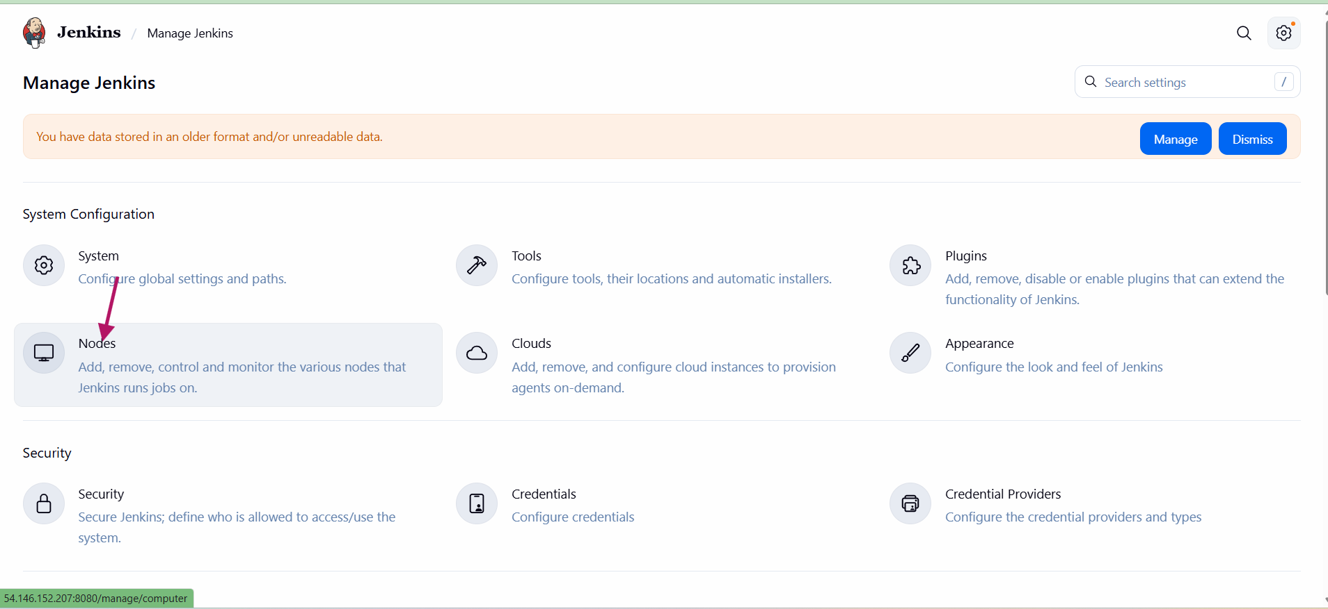

2.click on new node 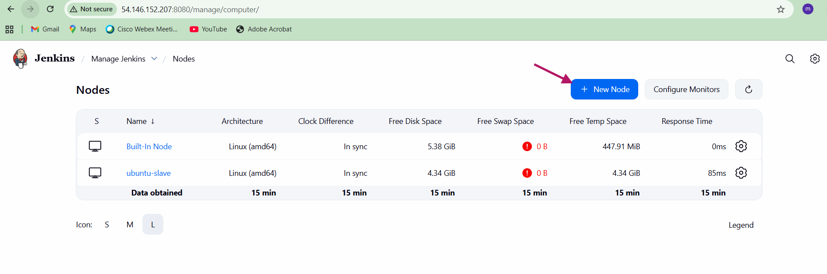

3.provie the node and click on perminant then click on create.

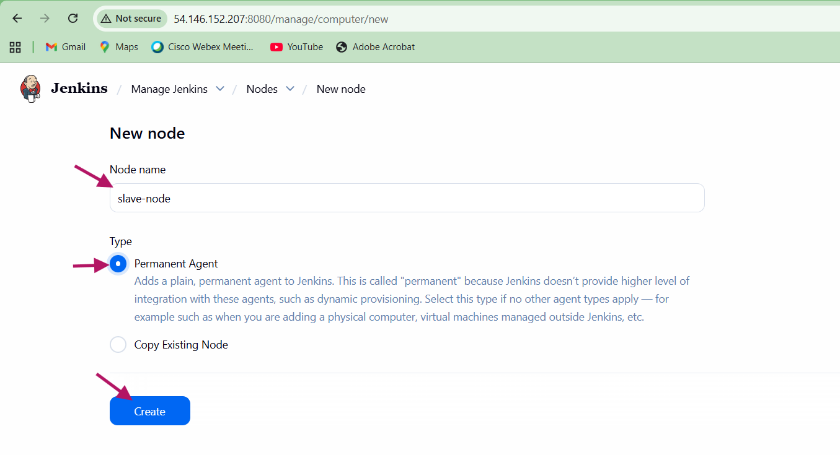

4.provide name of the node and decription and root home directory. 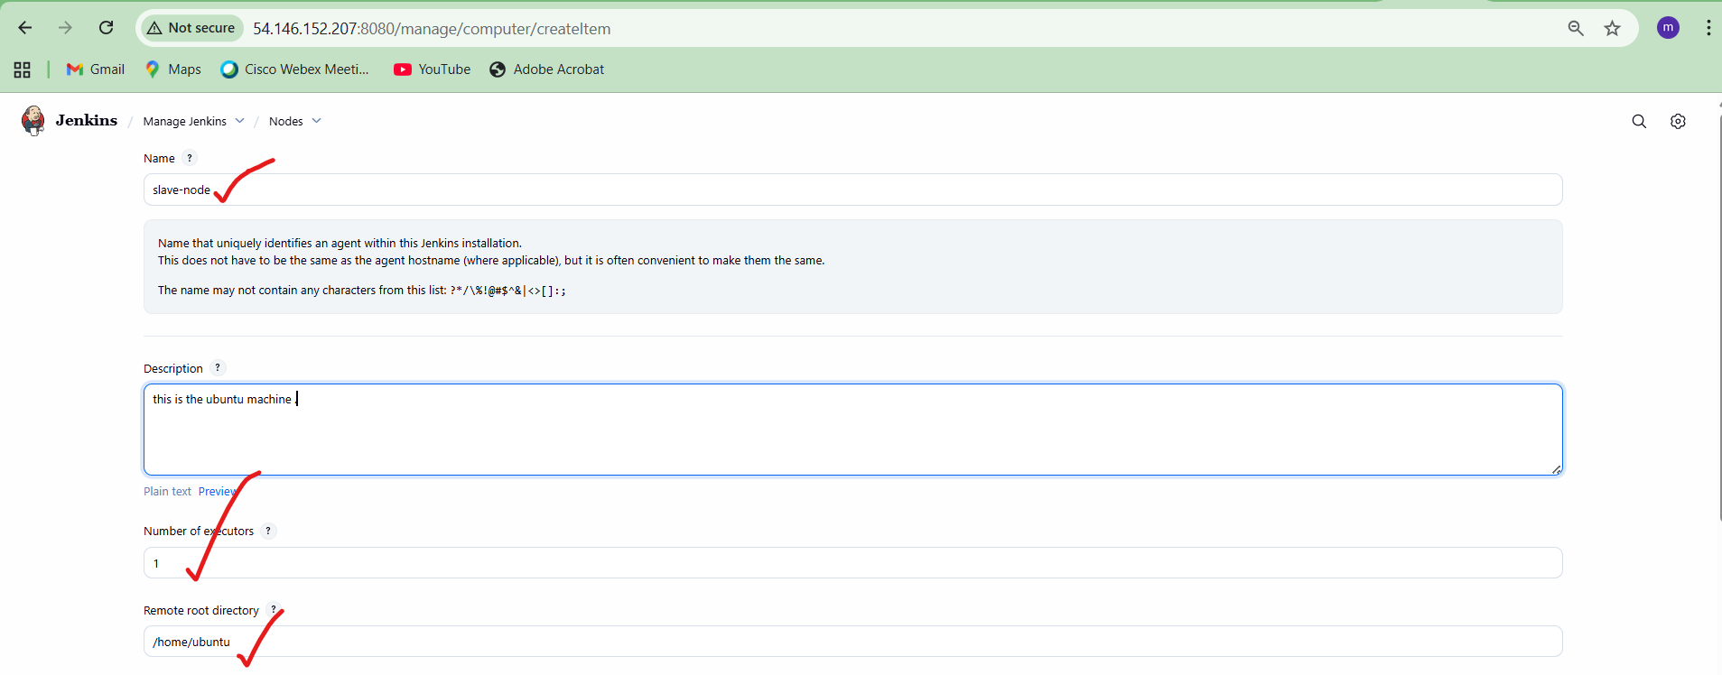

5.provide the lable name which will be used during job building of the jenkins job

6.select the launch methond as launch agents via SSH and provde hostname of the slave node node

$ hostname -i

172.31.24.247

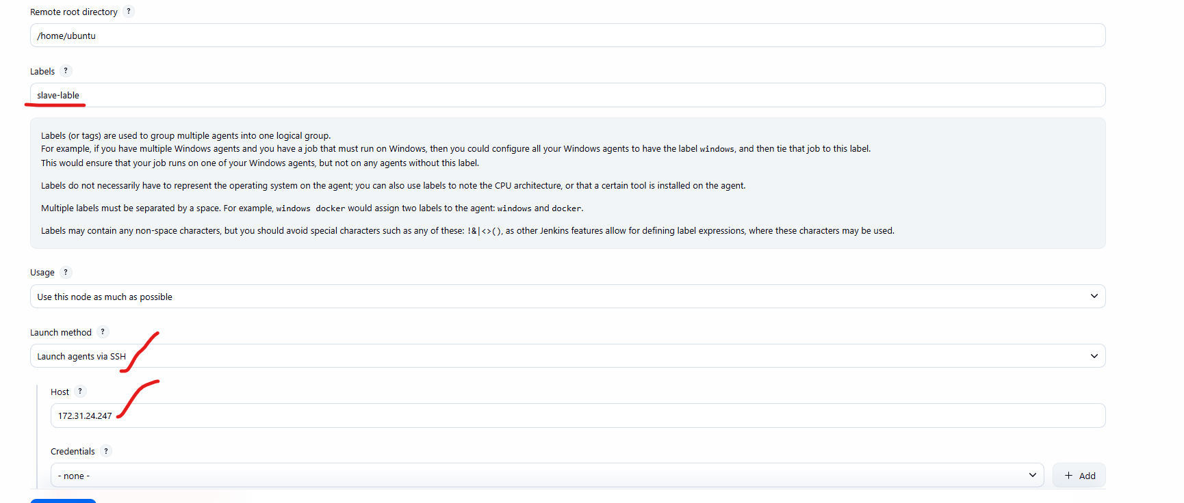

7.we have to set the credentials by click on add

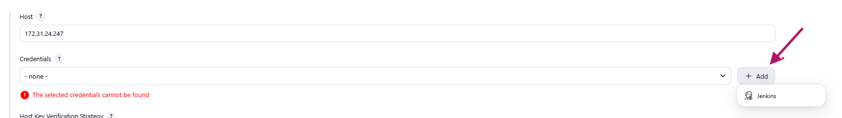

8.provide the id and username of the node machine

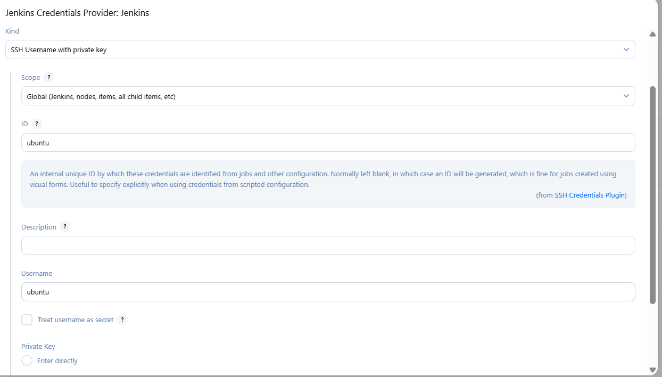

9.provide the private key of the node machine 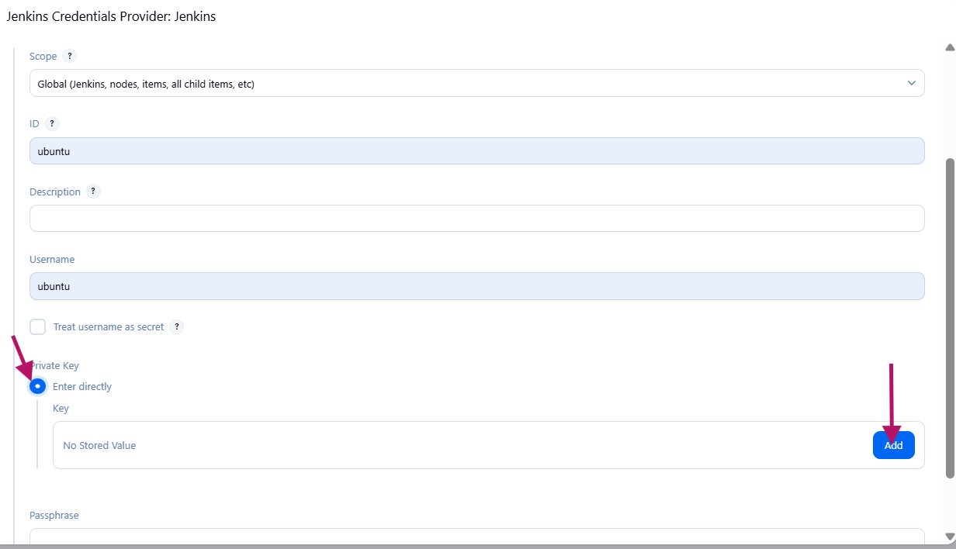

10. provide the .pem content of the slave/node machine

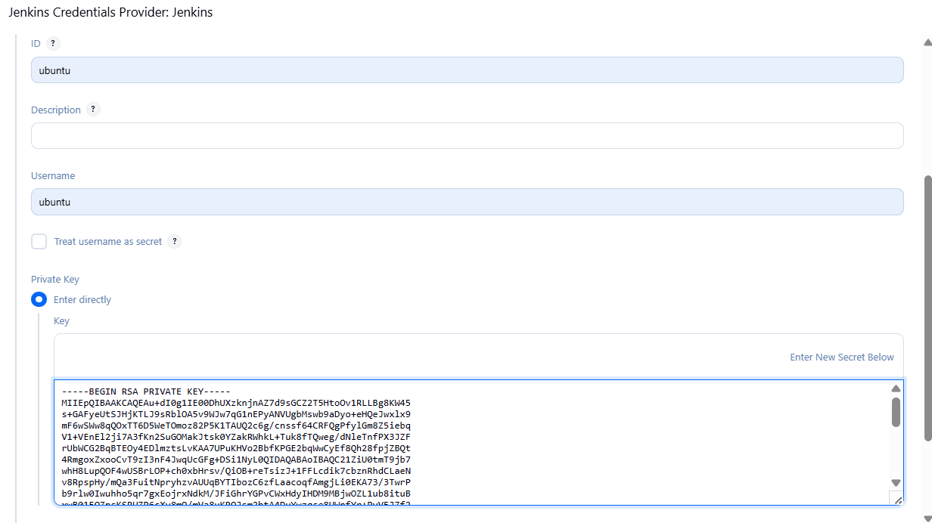

11.select the node machine credentials which are created in the above steps

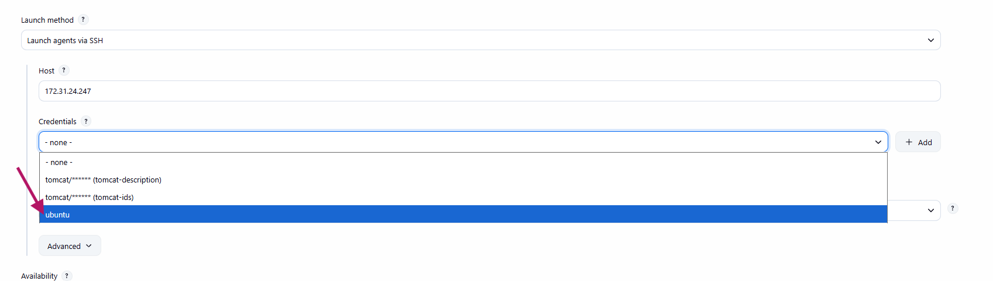

12. select the Host key verification strategy as manually trusted key verification strategy. And save it.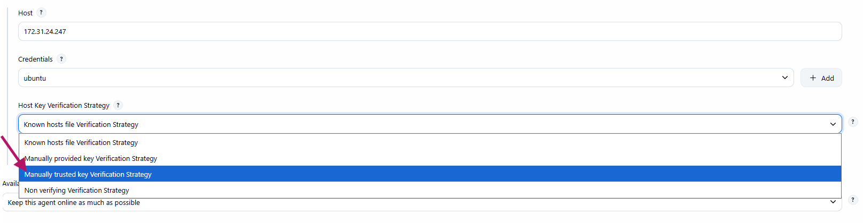

13. validate the node status it should be online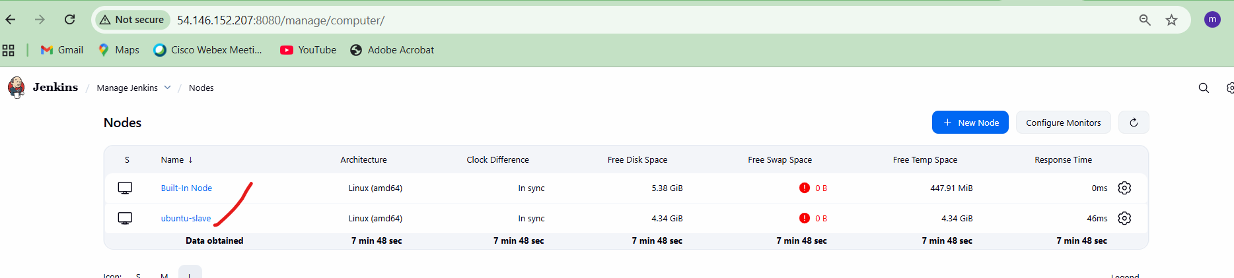

**Step-4:**creating the job by setting the slave node to run the job.

Provide the restrict where this project can be run .

And provide the label name for the slave node.

And save and build the job.

**Step-5:**

Validate the console output where the job is running.

It should run the slave node and job will be run on

**/home/ubuntu/workspace/<job>**